Project Phase Template Requirements Specification

Scope

Overview
A project is usually executed in a predefined set of phases for a particular customer. Requiring the user to manually define the phase hierarchy is laborious and unnecessary. The component provides a template mechanism to handle this scenario. Templates are stored as XML and can be added without code changes.

Logic Requirements

Phase Template
Phase template is a set of predefined project phases and their dependencies. The phases will not have start time defined.

XML Storage
A set of project phases are stored as a template and will be assigned a template name. An XML schema should be designed to store a single template. The API should have a way to return all the configured template names.

Phase Generation
Given a template name and an optional project start date, the project phases can be generated based on the template.

Start Date Strategy
If project start date is not provided, it will be generated from a pluggable strategy.

The default implementation should generate a relative time in a week. It could be configured to return 9:00 am next Thursday.

Required Algorithms
No specific algorithms are required.

Example of the Software Usage
Upon creation of a project, user will provide a start date for the project and pick a template to use. The project’s phases are generated and presented to the user. User can further make adjustments to the timeline and save the phases.

Future Component Direction
User interface can be designed to edit the phase templates.

Interface Requirements

Graphical User Interface Requirements
None.

External Interfaces
Design must adhere to the interface diagram definition. Designer can choose to add more methods to the classes/interfaces, but must keep the ones defined on the diagram as a minimum. Source files can be found in the distribution.
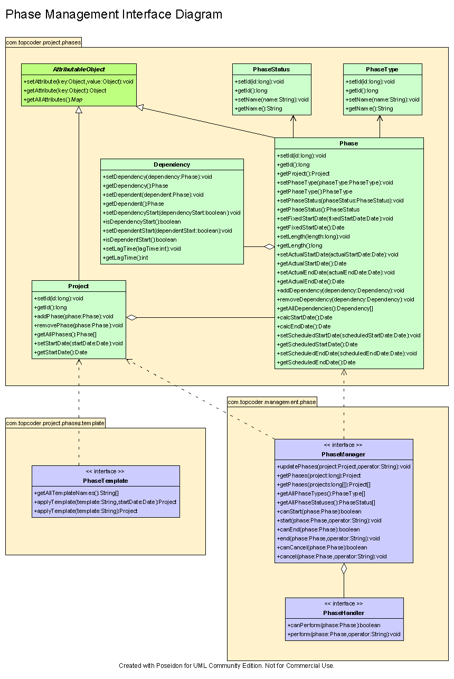

Environment Requirements
- Development language: Java1.4
- Compile target: Java1.4

Package Structure
com.topcoder.project.phases.template

Software Requirements

Administration Requirements

What elements of the application need to be configurable?
- The strategy to generate project start date
- The fixed time in a week in the default start date strategy

Technical Constraints

Are there particular frameworks or standards that are required?
XML

TopCoder Software Component Dependencies:
- Project Phases
- Configuration Manager

**Please review the TopCoder Software component catalog for existing components that can be used in the design.

Third Party Component, Library, or Product Dependencies:
None.

QA Environment:
- Solaris 7
- RedHat Linux 7.1
- Windows 2000
- Windows 2003

Design Constraints
The component design and development solutions must adhere to the guidelines as outlined in the TopCoder Software Component Guidelines.

Required Documentation

Design Documentation
- Use-Case Diagram
- Class Diagram
- Sequence Diagram
- Component Specification

Help / User Documentation
- Design documents must clearly define intended component usage in the ‘Documentation’ tab of Poseidon.

